Contents
1. Introduction 1
2. Adding an employee 1

Introduction

CoreHR have a piece of functionality called the Job Seekers Register (“JSR”), which can be used to identify employees whose contracts are ending and who should be considered for redeployment within their companies.

The JSR is, in essence, just a register – adding an employee’s contract to it does not automate any kind of employment processes. However, the existence of a central register of “job seekers” may support the Senior Appointments team’s with the Priority Candidate Support Scheme (“PCSS”).

There are two ways to use the JSR:

- Automatically – system rules can be configured to automatically identify employee contracts which are due to end and add them to the JSR.**
- Manually – a flag called “JSR Override” can be used to manually add an employee’s contracts to and remove them from the JSR.

**The automatic process requires a lot of careful thought about what types of contracts should be considered “eligible” for addition to the JSR. Rules can be configured based on organisational hierarchy and appointment details – e.g. all fixed-term contracts at Standard Grade 7 within a given department, or all contracts of any kind on the Marie Curie Student pay grade. These rules must be configured and thoroughly tested to ensure that they are working as desired. In the interests of speed, the Senior Appointments Team have opted not to adopt the automatic JSR process at this time.

The manual process for using the JSR is outlined below.

Adding an employee’s contract to the JSR

 | NB: The JSR functionality exists within CoreHR’s back-office. To access it, you must launch the back-office from CorePortal.

Navigate to: CorePersonnel > Employee Search > Person Profile

On the Employee Search screen, enter the name or personnel number of the employee you wish to add to the JSR. Double-click their record to enter the Person Profile screen.

In the upper right corner of the screen, go to the Select Detail menu and choose the option “Job Seekers”:

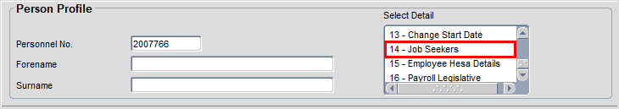

You will be taken to the Job Seekers Register screen.

 | NB: This is not the JSR itself, it’s just the area where you can add/remove a single employee.

In the lower half of the screen, you will see a list of the employee’s current appointments. Two fields are of interest here (circled in red):

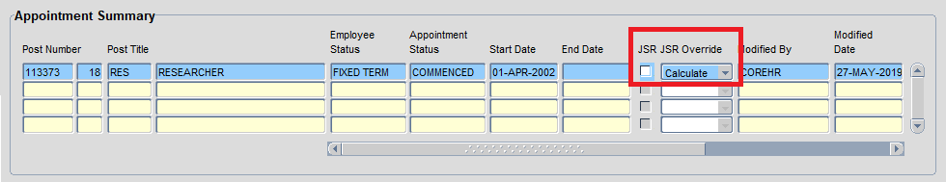

- JSR – this flag indicates whether the contract is already on the Job Seekers Register. It will be ticked once the record has been added by the overnight database job. This flag cannot be updated by users; it is a system-only flag.
- JSR Override – This field determines whether the automatic or manual process will be used to add a contract to the JSR.

JSR Override has three options:

- Calculate – use the eligibility rules configured in the system to determine whether the contract in question is eligible to be added to the JSR.
- Yes – add the contract to the JSR manually, ignoring any eligibility criteria which may exist in the system.
- No – never add the contract to the JSR, regardless of whether it meets any eligibility criteria.

To add a contract to the JSR, change the JSR Override field to “Yes”.

A warning message will appear. Click “Yes” to dismiss it:

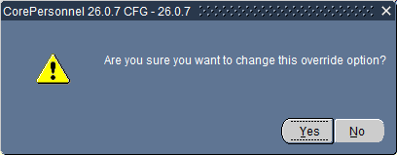

Save your changes.

An overnight process (PERS_JOB_SEEKERS_REGISTER_PROC.PROCESS_J) will run in CoreHR, which will pick up the record you have amended and added it to the JSR.

The following day, if you return to the employee record, you will see the JSR flag is now ticked:

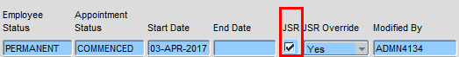

Removing an employee’s contract

If, for whatever reason, an employee no longer needs to be on the Job Seekers Register, it’s simple to remove them.

Navigate to: CorePersonnel > Employee Search > Person Profile

Go back to the employee record and choose “Job Seekers” from the Select Detail menu. On the Job Seekers Register screen, change the JSR Override field from “Yes” to “Calculate”:

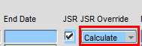

The warning message will appear asking you to confirm you wish to make this change. Click “Yes” and save your changes. The overnight database job will run again and remove the employee contract from the JSR.

The following day, if you return to the employee record, you will see the JSR flag is no longer ticked.

